
Beechen Hall, Wildfell Close, Walderslade, Chatham, Kent. ME5 9RU
01634 861237
clerk@boxleyparishcouncil.gov.uk
Clerk: Mrs Daniela Baylis
Assistant Clerk: Heidi Pearson
Finance Assistant: Nichola Carter

www.boxleyparishcouncil.gov.uk

A G E N D A
-
To All Members of the Council, Press and Public

There will be a meeting of the Finance & General Purposes Committee on 23 March 2026 at Beechen Hall, Wildfell Close, Walderslade, ME5 9RU at 6.00pm. The Chairman will assume that all Members will read the reports before attending the meeting. Members are asked to submit questions to the Clerk in advance of the meeting to enable a response to be given at the meeting.

1. | Apologies and Non-Attendance
2. | Declaration of Interests, Dispensations, Predetermination or Lobbying.  Members are required to declare any interests, dispensations, predetermination or lobbying on items on this agenda.
3. | Motion to exclude the Press and Public from items in the Confidential Section
4. | Minutes of the meeting of 12 January 2026 (Pages 3-5)  To consider the minutes of the meeting and if in order sign as a true record.
5. | Matters arising from the minutes
5.1 | None.
5.2 | Any other matters arising from the minutes, but not on the agenda.
Public Session at the discretion of the Chairman. Parishioners may address the meeting with regard to any item on the Agenda (time limited to 3 minutes per person). Items not on the Agenda must be submitted to the Clerk in advance of the meeting. Non-parishioners are only able to address the meeting at the invitation of the Chairman

6. | Financial
6.1 | Bank Reconciliations (Verbal report to be given at the meeting)
6.2 | Bank Account Totals (Page 5)
6.3 | Banking (Page 5)
6.4 | Summary of Receipts and Payments (Page 6-10)
6.5 | Net Position by Cost Centre and Code (Page 11-13)
6.6 | Finance General (Page 13)
6.7 | Ear Marked Reserves annual review (Page 14-15)
6.8 | To create a new reserve for Professional Representation for the Medway Local Plan (Page 15)
6.9 | Expenditure from the Contingency Fund (Page 16)
6.10 | Regular Payments Review (Page 16-17)
6.11 | Insurance Cover – Annual Review (Page 17)
7. | Policies and Procedures for Review
7.1 | Finance and General Purposes Committee Terms of Reference (Page 17-18) – no change
8. | New Office Equipment/revised service provision (Page 19-20)
9. | 5 Year Strategic Plan (Page 20)
10. | Internal Auditor (Page 20-22)
11. | Matters for Information
 | To receive information.
12. | Items for Next Agenda
 | Councillors’ reports and requests for items to be included on the agenda to be submitted no later than 9 July 2026.
13. | Date of Next Meeting
 | 20 July 2026 at Beechen Hall
CONFIDENTIAL SECTION

14. | Personnel
14.1 | TOIL, training, leave and sickness cover. (to follow).

Daniela Baylis

Daniela Baylis
Clerk to the Council. Date: 18 March 2026

In accordance with policy the meeting should last no longer than 2 hours but the Chairman has power to extend it by 30 minutes.

Legislation allows for meetings to be recorded by anyone attending. Persons intending to record or who have concerns about being recorded should please speak to the Clerk.

Note to all councillors: You are welcome to attend and speak at meetings of committees of which you are not a member but only committee members may vote

Supporting agenda papers for the Meeting of the Finance & General Purposes Committee on Monday 23 March 2026

The Chairman will assume that these have been read prior to the meeting.
__________________________________________________________
Councillors wishing to suggest changes to any policy document or procedure in this agenda should notify the office, in writing, at least three working days in advance of the meeting. This will allow details to be circulated at the meeting (or in advance if particularly contentious). Any questions on the Financial Reports should be put to the Clerk before the meeting to enable answers to be given at the meeting.

Item 4. Minutes of the meeting held on 12 January 2026

Minutes of the Boxley Parish Council Finance and General Purposes Committee Meeting Held at Beechen Hall, Wildfell Close, Walderslade on 12 January 2026 at 6.00 pm

Councillors present: Cllr A Brindle, Cllr I Davies, Cllr J Akehurst, Cllr V Jones,
Cllr C English, Cllr S Sampangi and Cllr S Thompson together with Mrs D Baylis – Clerk

1. | Apologies and non-Attendance  Cllr Zand – apologies received  Cllr Mclean - absent
2. | Declaration of Interests, Dispensations, Predetermination or Lobbying  None.
3. | Motion to exclude the Press and Public from items in the Confidential Section.
 | It was proposed by Cllr English, seconded by Cllr Brindle and all agreed to exclude the press and public from items in the confidential section.
4. | Minutes of the meetings of 22 September 2025  The minutes of the meeting were agreed.
5 | Matters Arising from the Minutes
Minute 3998 Item 5. Cllr Jones asked for an update on the TOIL policy. Cllr Akehurst confirmed that the policy is in place. The Clerk would continue to generate TOIL for all evening meetings until an alternative could be worked out.
Minute 3998 item 5. Cllr Thompson asked about the photocopier lease and if a timetable had been made for renewal dates. The Clerk confirmed that a full timetable of renewal dates was on the Policies and Procedures review calendar that had been on the December Parish Council Agenda.
Minute 3999 item 7.1. The IT Policy would be re-drawn and represented at the F&GP meeting in March. The Clerk needed to ensure that it complied with the new Assertion 10.
Minute 3999 item 9. Cllr Jones asked for an update. The Clerk had a quotation from KCC auditors based on last years’ prices. Once the prices for next year were received together with an explanation of what their in depth audit consisted of this would be presented to Councillors at the next meeting for consideration together with any other quotations received.

As no members of the public were present the meeting was not adjourned.
6. | Financial
6.1 | Bank Reconciliations  Cllr Brindle had only part completed the December reconciliation due to adverse weather conditions on the day she went to the office. Action - Cllr Brindle.
6.2 | Bank Account Totals  Noted.
6.3 | Banking  The Clerk explained the issues with the Nationwide Building Society Accounts and their anti-money laundering review process. It was proposed by Cllr English, seconded by Cllr Sampangi and all agreed to close the 2 accounts if the issues could not be resolved. Action - Clerk
6.4 | Summary of Receipts and Payments  Noted.
6.5 | Net Position by Cost Centre  Noted.
6.6 | Finance General  The Clerk reported that the new Visa card could be used in shops to make purchases.
6.7 | Precept Tax Base Letter
 | Noted.
6.8 | To recommend the budget 2026/27
The Budgets were looked at. The training budgets for staff and Councillors were moved from F&GP to the Personnel Budget. It was agreed to add £3,000 to the Publicity budget to cover the cost of newsletters, leaflets etc. It was agreed to add £2,000 to the Community Engagement budget to cover more community based events. It was agreed to put £12,000 of unallocated reserves into an EMR for 5 Year Plan Projects.
Subject to the above amendments and any put forward by the Personnel Committee after their meeting on the 14 January 2026, it was proposed by Cllr English, seconded by Cllr Akehurst and all agreed to put the budget forward to full Council for approval.

6.9 | Budget Summary
 | Noted. This would need to be adjusted following the amendments made to the budget before presentation to full Council for approval.
6.10 | Financial Snapshot as at 5/1/2026
 | Noted. It was agreed that the EMR’s should be reviewed to indicate a timetable for usage. This would be looked at during the EMR review and must be coordinated with the 5 Year Plan. The Clerk said that a timetable of replacement of assets could be added to the new Asset register.
6.11 | To recommend a Precept for 2026/27
 | It was proposed by Cllr Brindle, seconded by Cllr English and all agreed to recommend a Precept amount of £296,840 to full Council for the year 2026/27, subject to any change following the Personnel Committee meeting on the 14 January 2026.
7. | Policies and Procedures for Review
7.1 | Policies Relating to staff
 | Noted as a reminder.
8. | 5 Year Strategic Plan
 | The draft would be on the next full Council agenda. A working party would be created to look at year 1 plans and create an outline timetable. Action - Cllr Thompson.
9. | Matters for Information.
 | No matters for information put forward.
10. | Items for Next Agenda
 | Cllr Jones asked for the Website to be put on the next full Council agenda.
11. | Date of Next Meeting
 | 23 March 2026 at 6.00 pm .
 | CONFIDENTIAL SECTION
12. | Personnel
12.1 | TOIL, training, sick leave and sickness cover
 | Cllr Akehurst gave a report from the Personnel Committee

Meeting closed at 7.39 p.m.
Signed as a correct record of the proceedings.

Chairman……………………………………… Date…………………………………

Item 6.1 Bank Reconciliations

Verbal report to be given at the meeting.

Verbal report to be given at the meeting.

Item 6.2 Bank Account Totals to17/03/26

Bank Account | Total at 17/03/26 | Notes
PC Unity Trust | 67,464.71 | Current account 0% interest
PC UTB Instant Access | 250,000 | 2.25% interest
Hall Unity Trust | 25,942.37 | Current account 0% interest
Hall UTB Instant Access | 40,000 | 2.25% interest
UTB Woodland Current Account | 641,930.94 | 2.25% interest
UTB Woodland Instant Access | 34,304.26 | Current account 0% interest
Woodland CCLA Investment Account |  | First £25,000 transferred 17.3.26 with remaining £575,000 to follow
Nationwide Beechen Hall | 85,070 | 3.4% interest
Nationwide Parish Council | 131,903 | 3.4% interest
Coop General Account | 0 | Cheque received 17.3.26
Total | 1,276,615.28
Restricted Walderslade Woodlands EMR | 676,235.20 | Can only be used for maintenance of Walderslade Woodlands in BPC ownership
Total of all other EMR’s | 444,775.66 | All other named reserves for specific purposes
Total minus EMR’s | 155,604.42

Item 6.3 Banking

The Coop account is closed and a cheque for the closing balance was received on the 17 March 2026. This will be paid into the PC UTB account and then transferred into the PC Instant Access.

£25,000 was transferred from the Woodland Instant Access account into the new woodland current account. This amount has been transferred to the new CCLA investment account. The remining £575,000 will be transferred shortly the same way.

A new bank totals form will be produced for the meeting with that days figures.

Item 6.4 Summary of Receipts and Payments

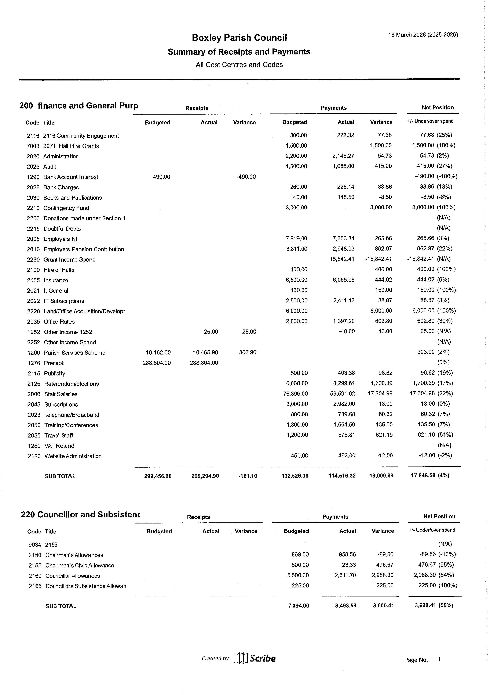
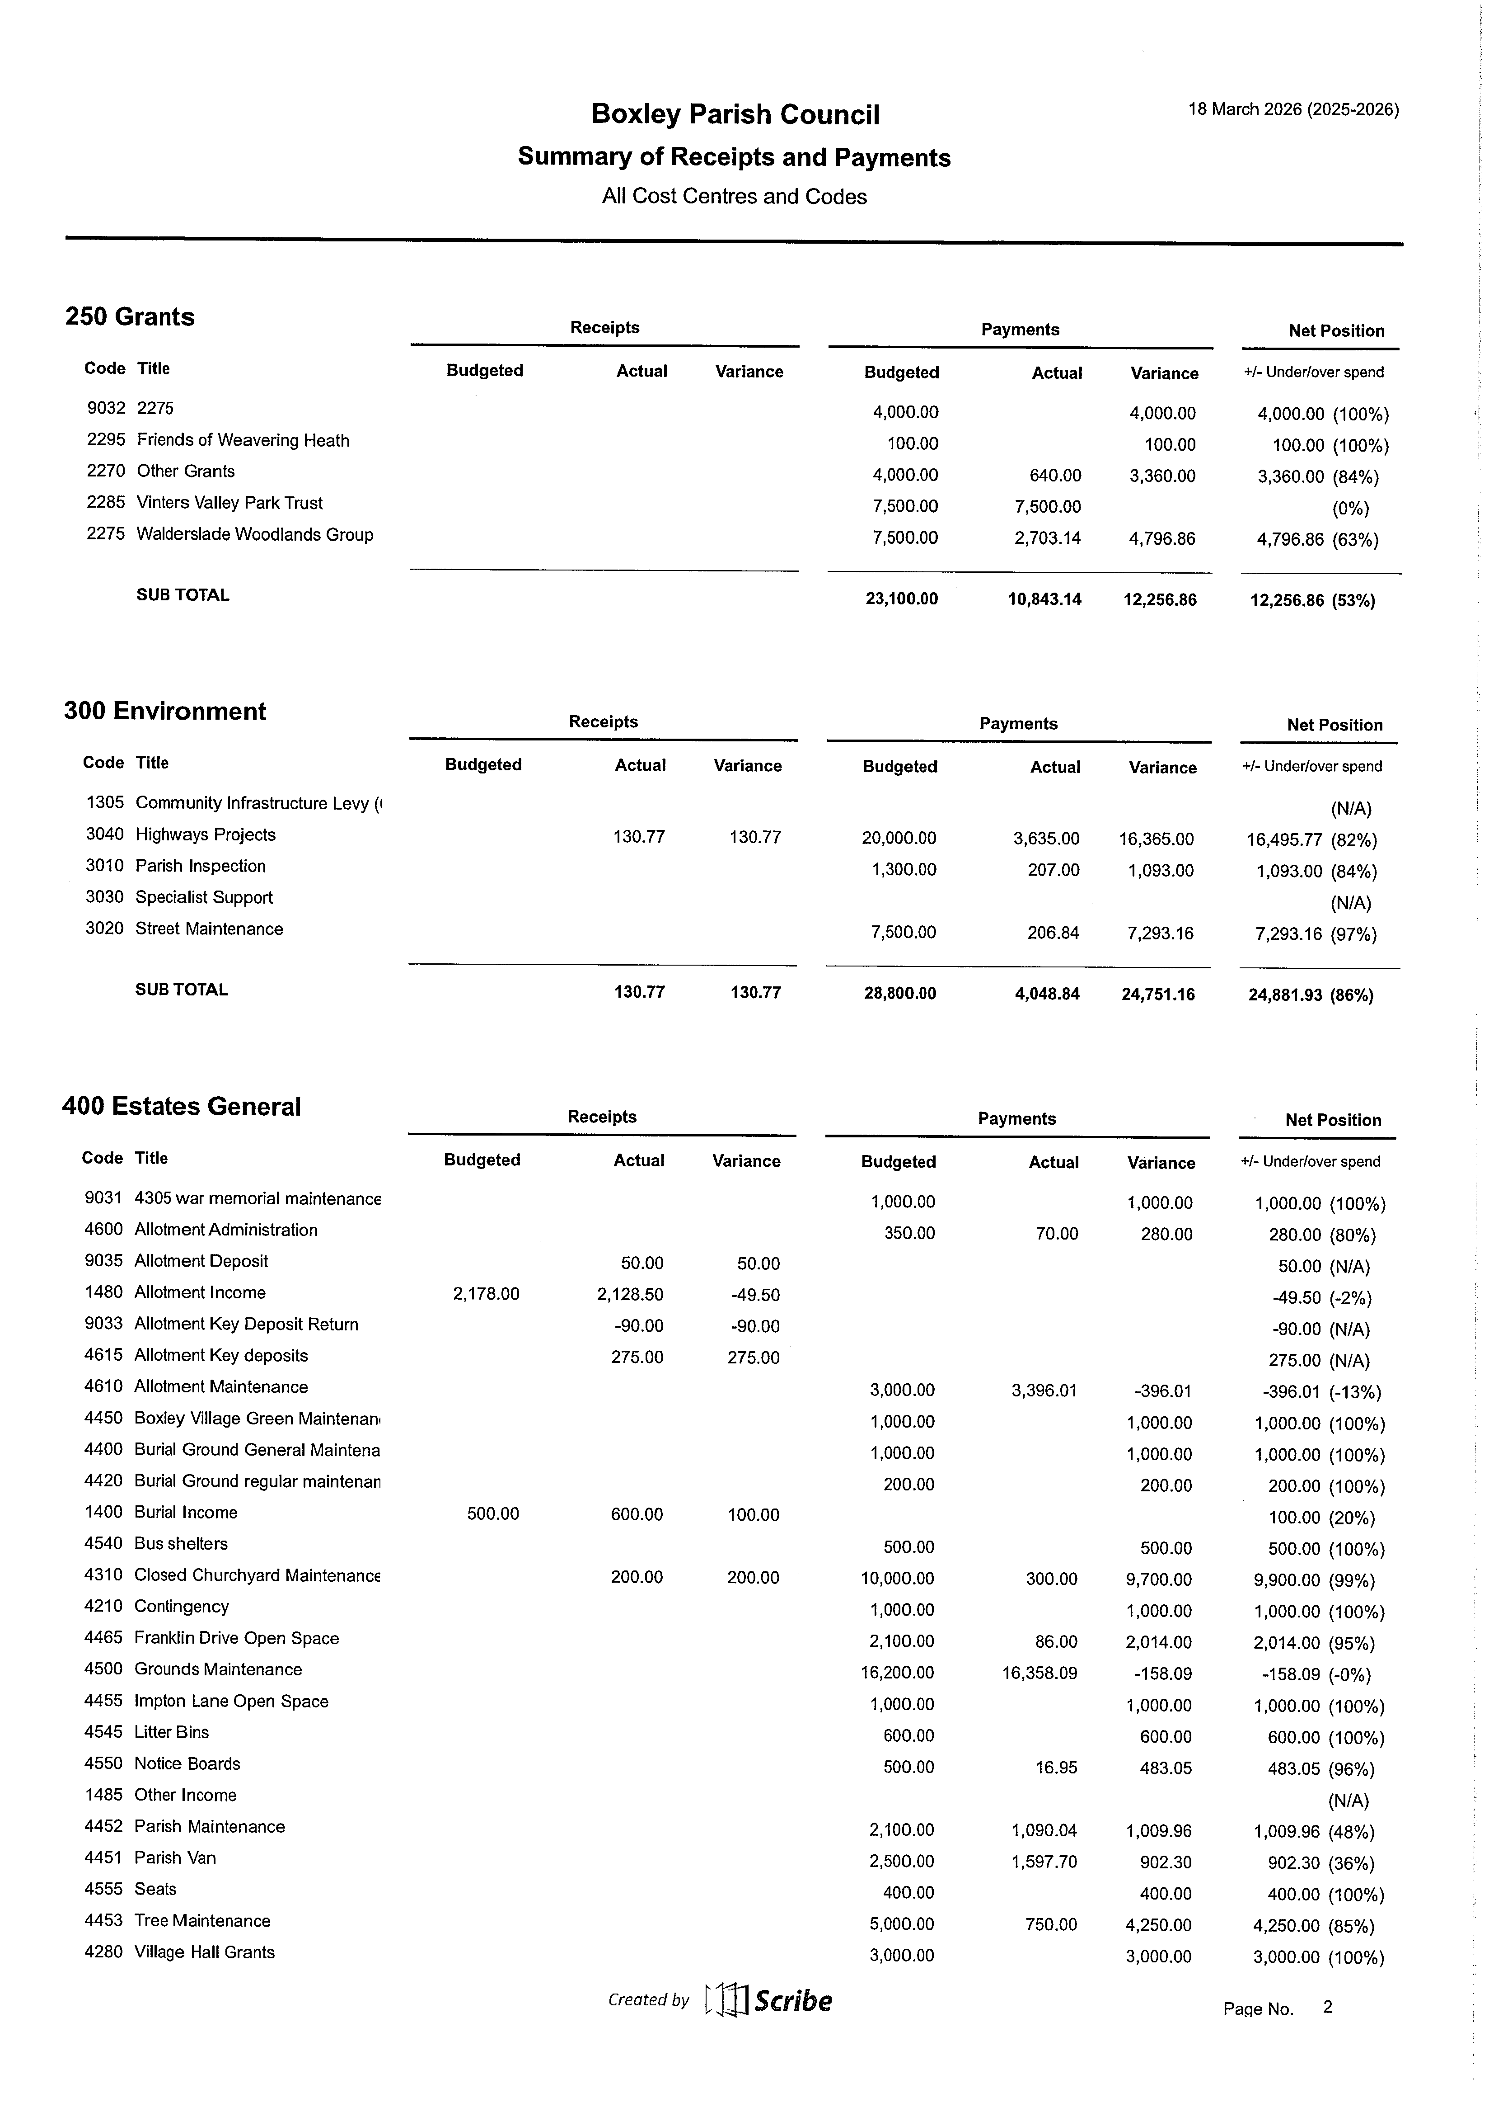
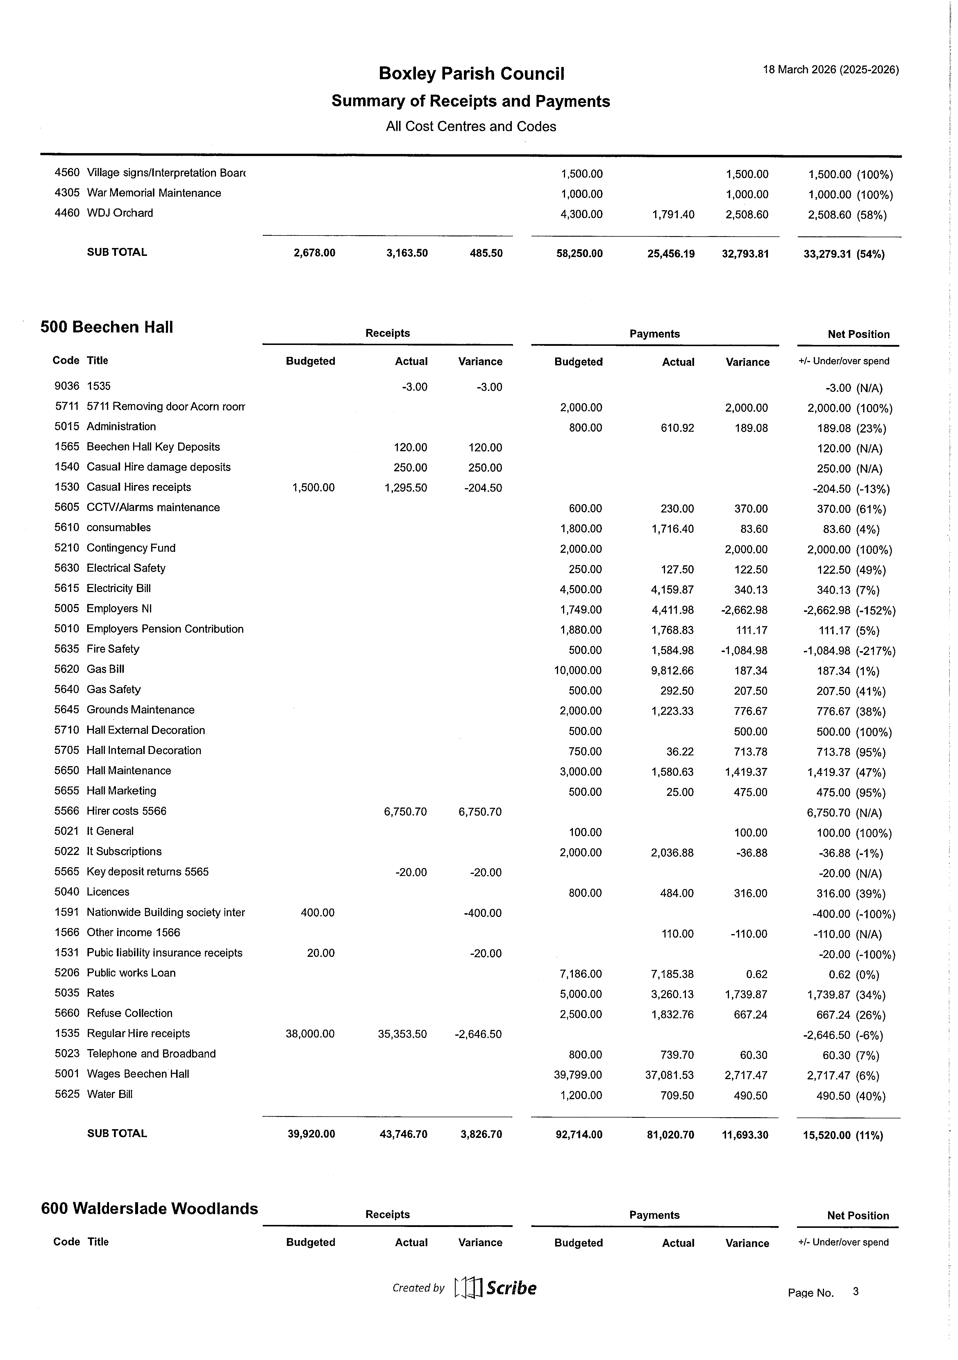
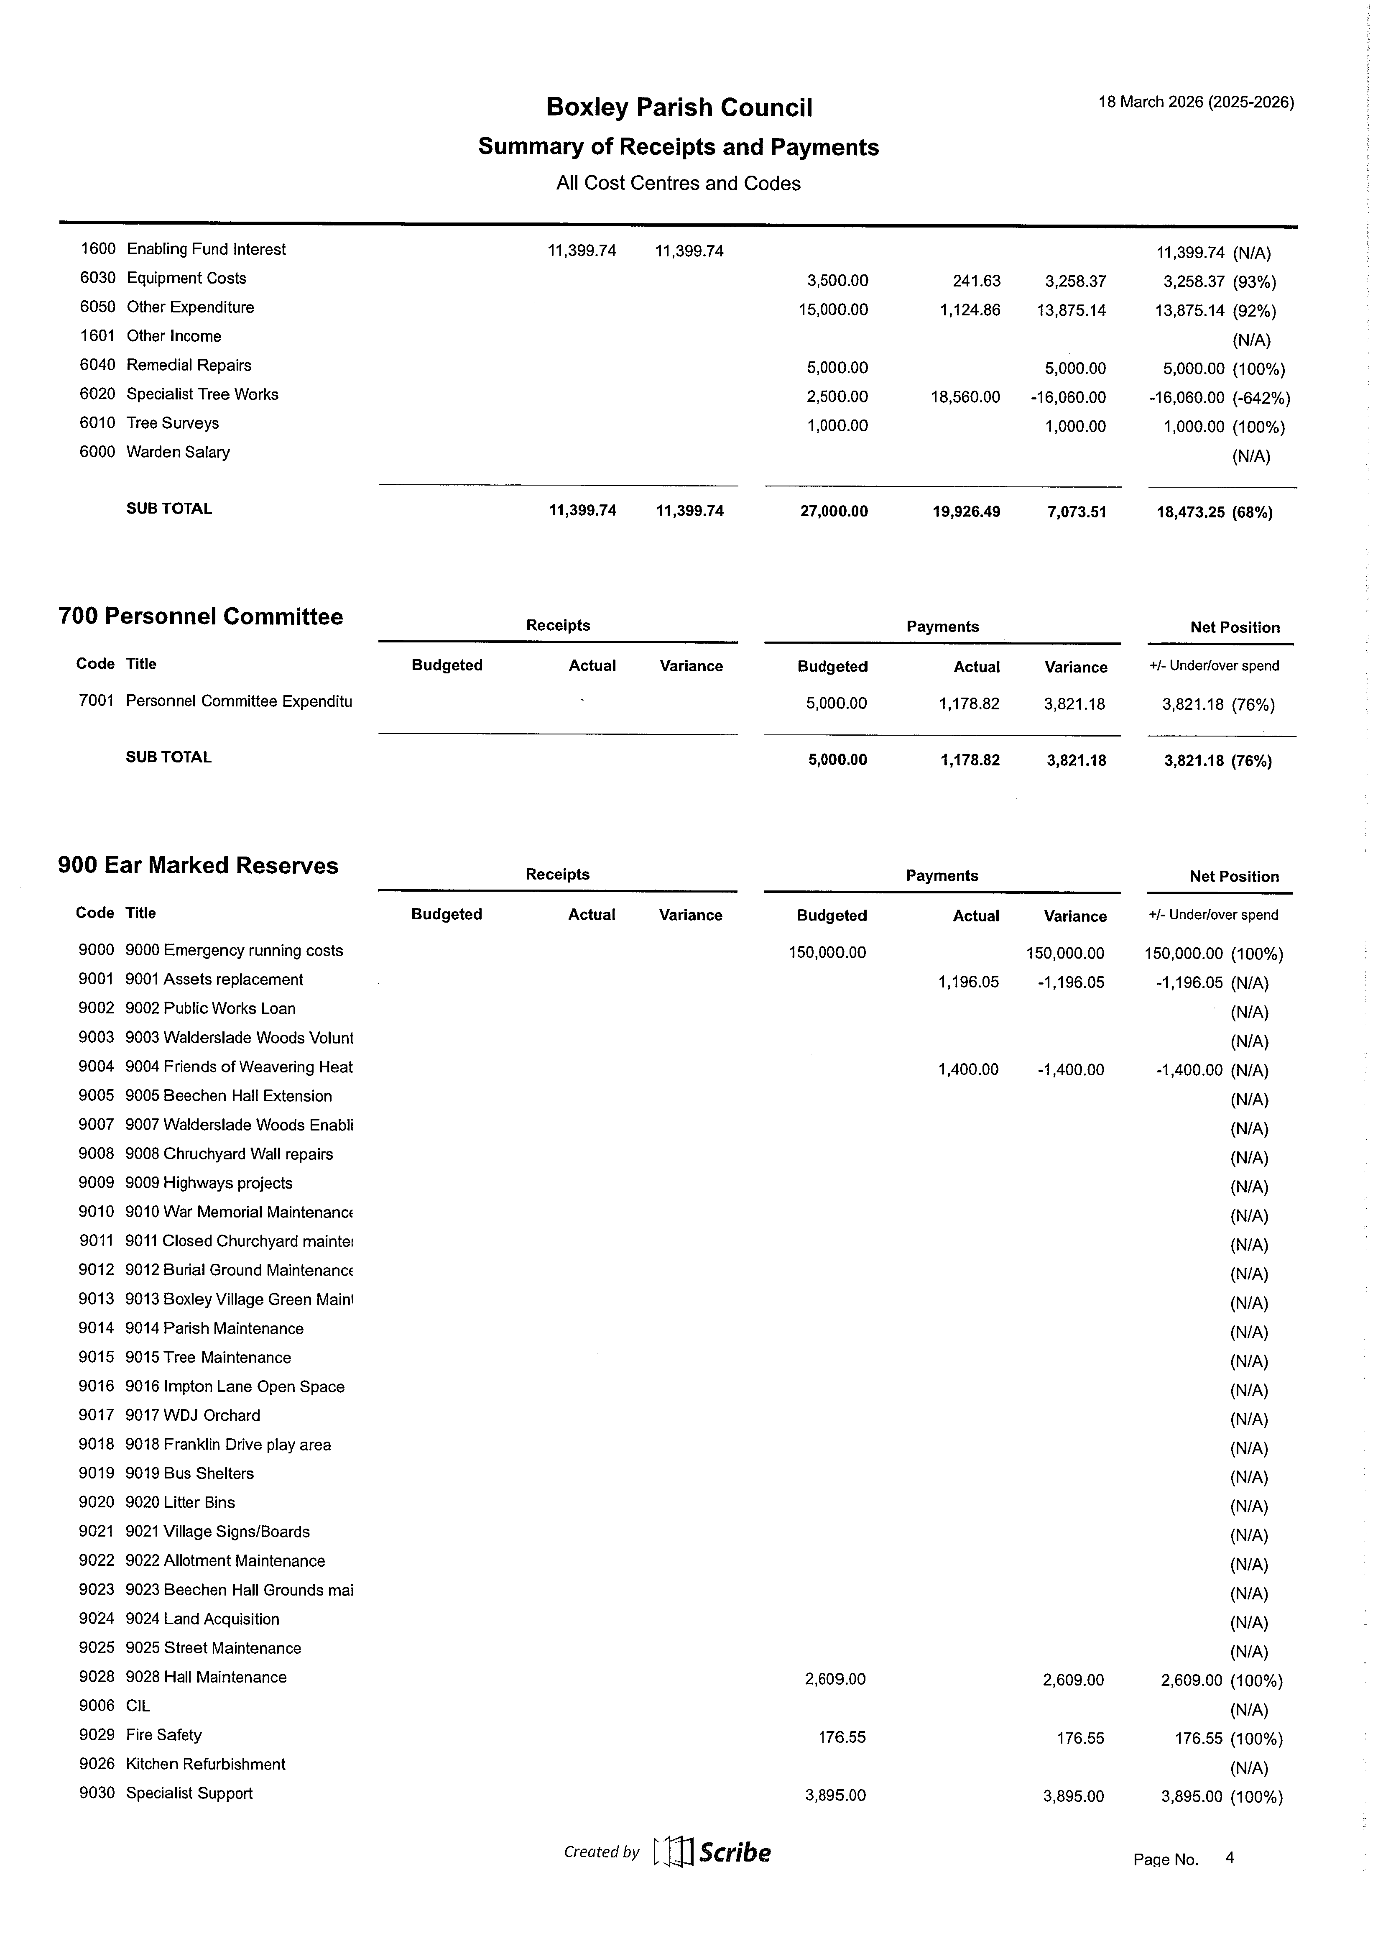


Item 6.5 Net Position by Cost Centre and Code

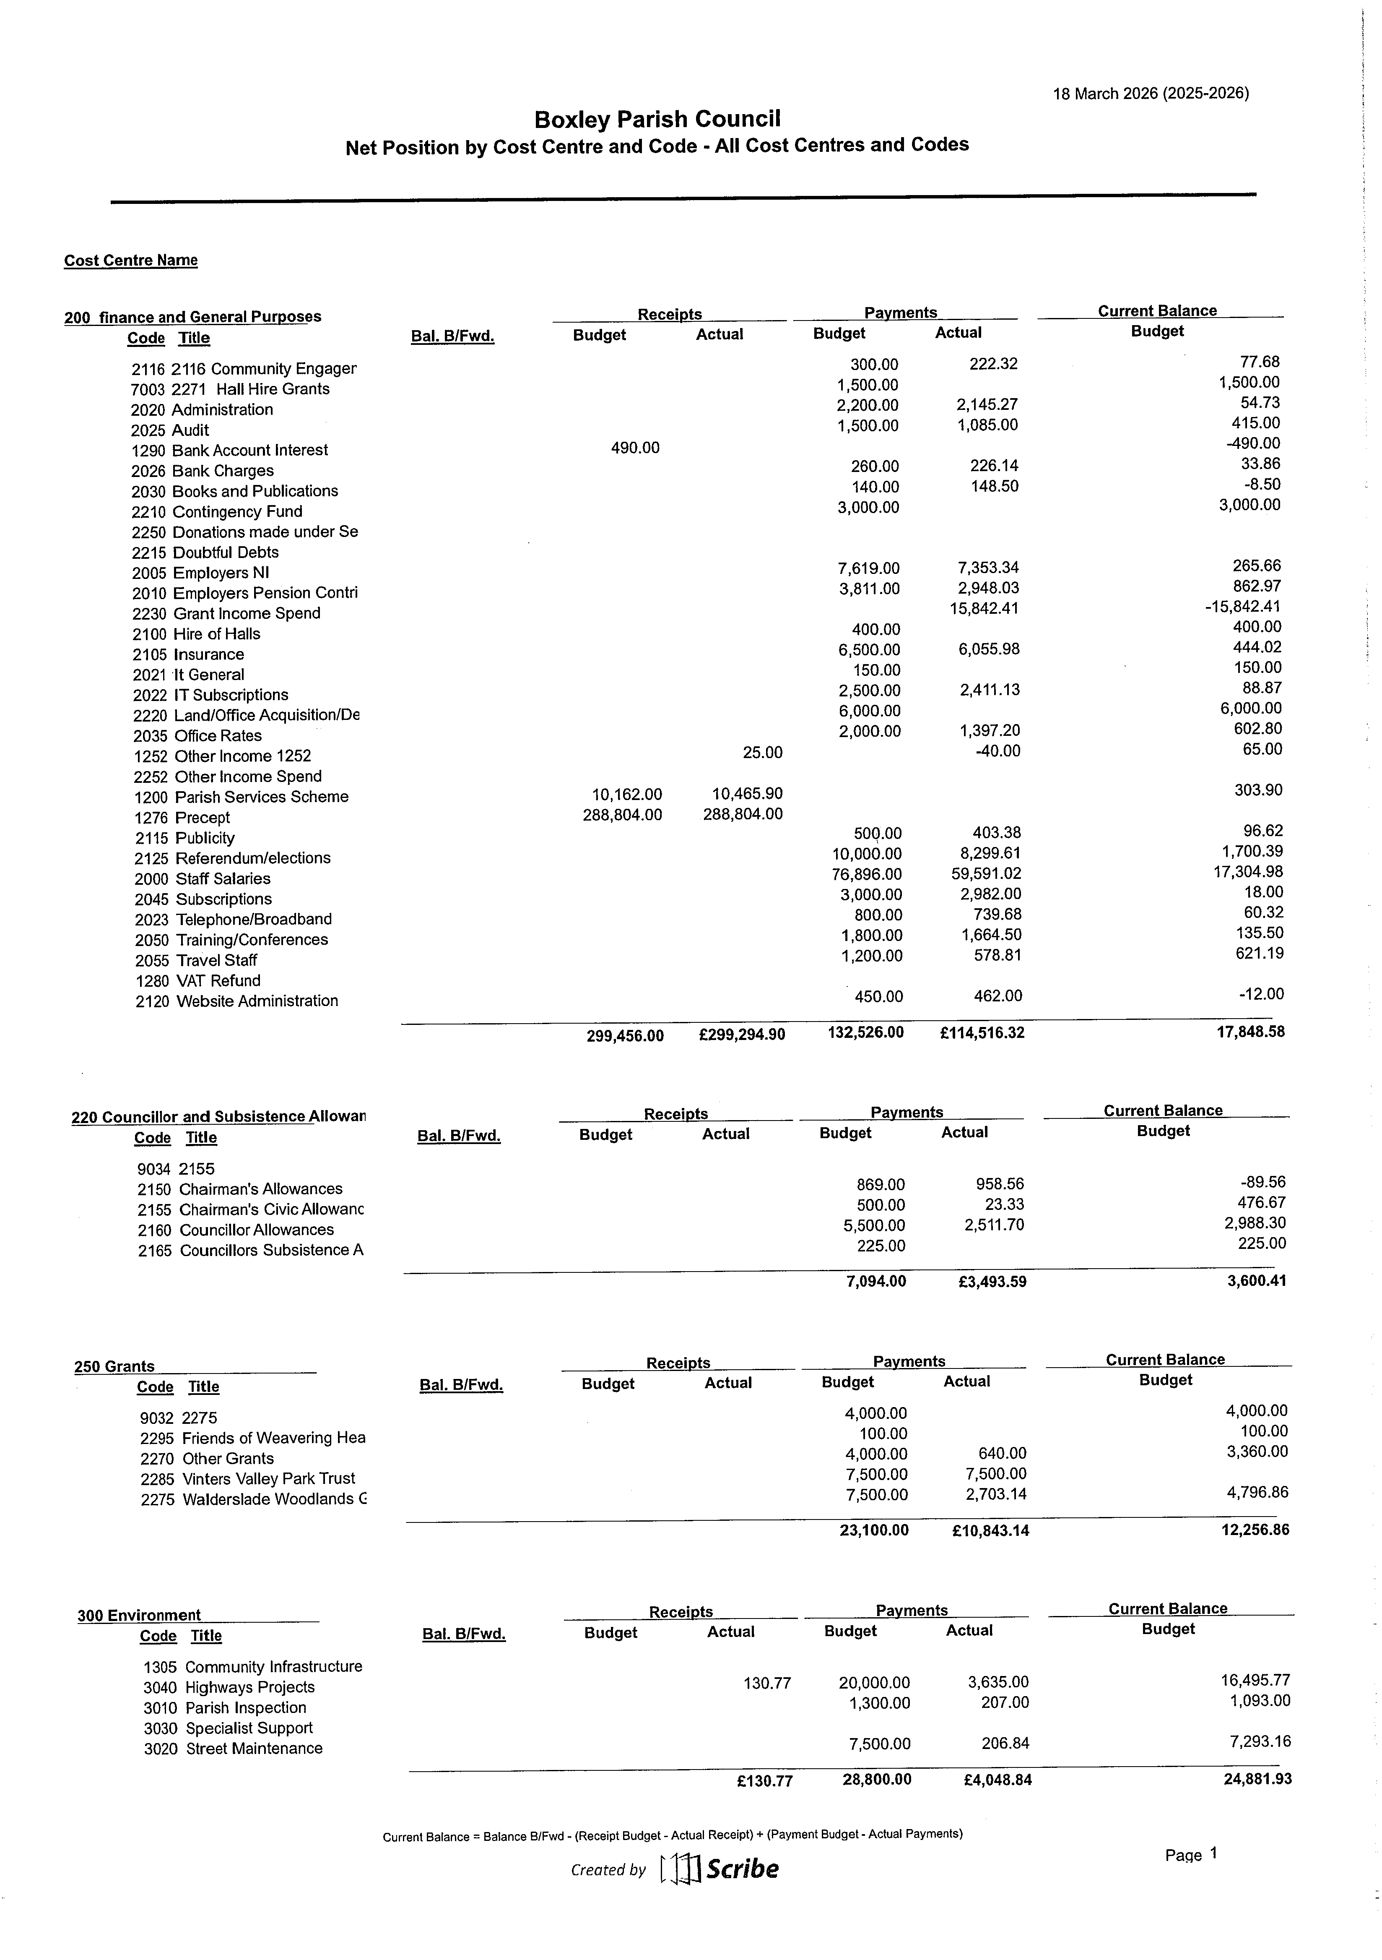
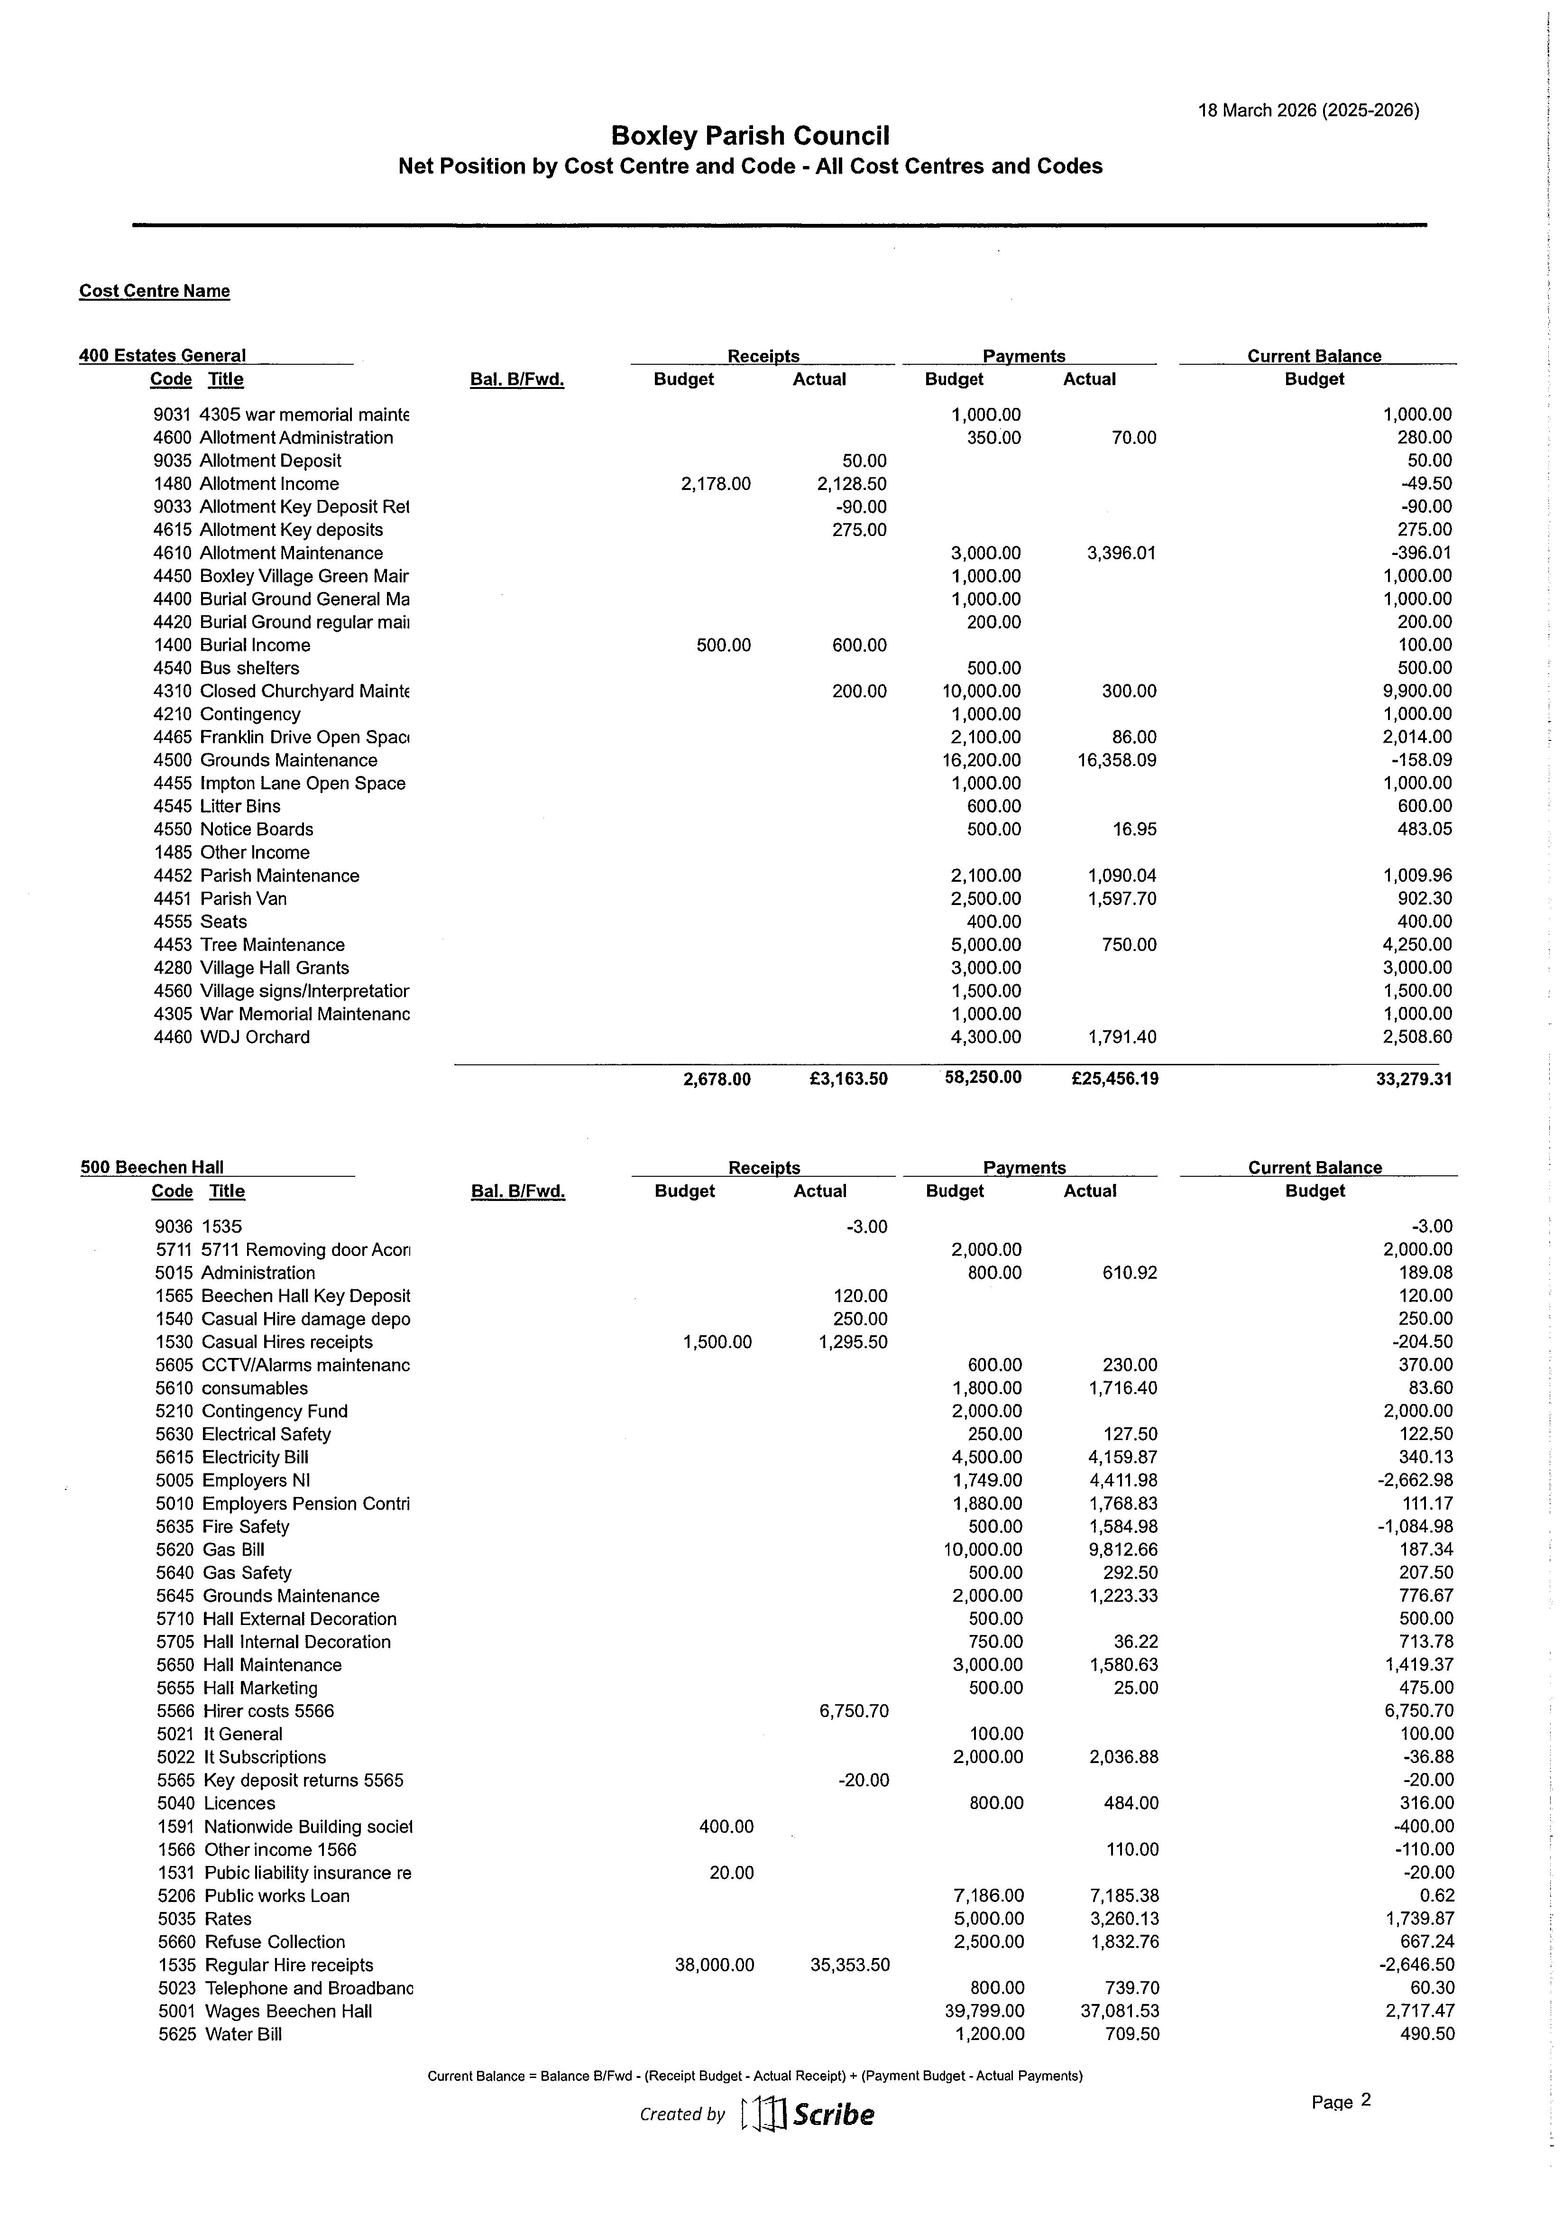
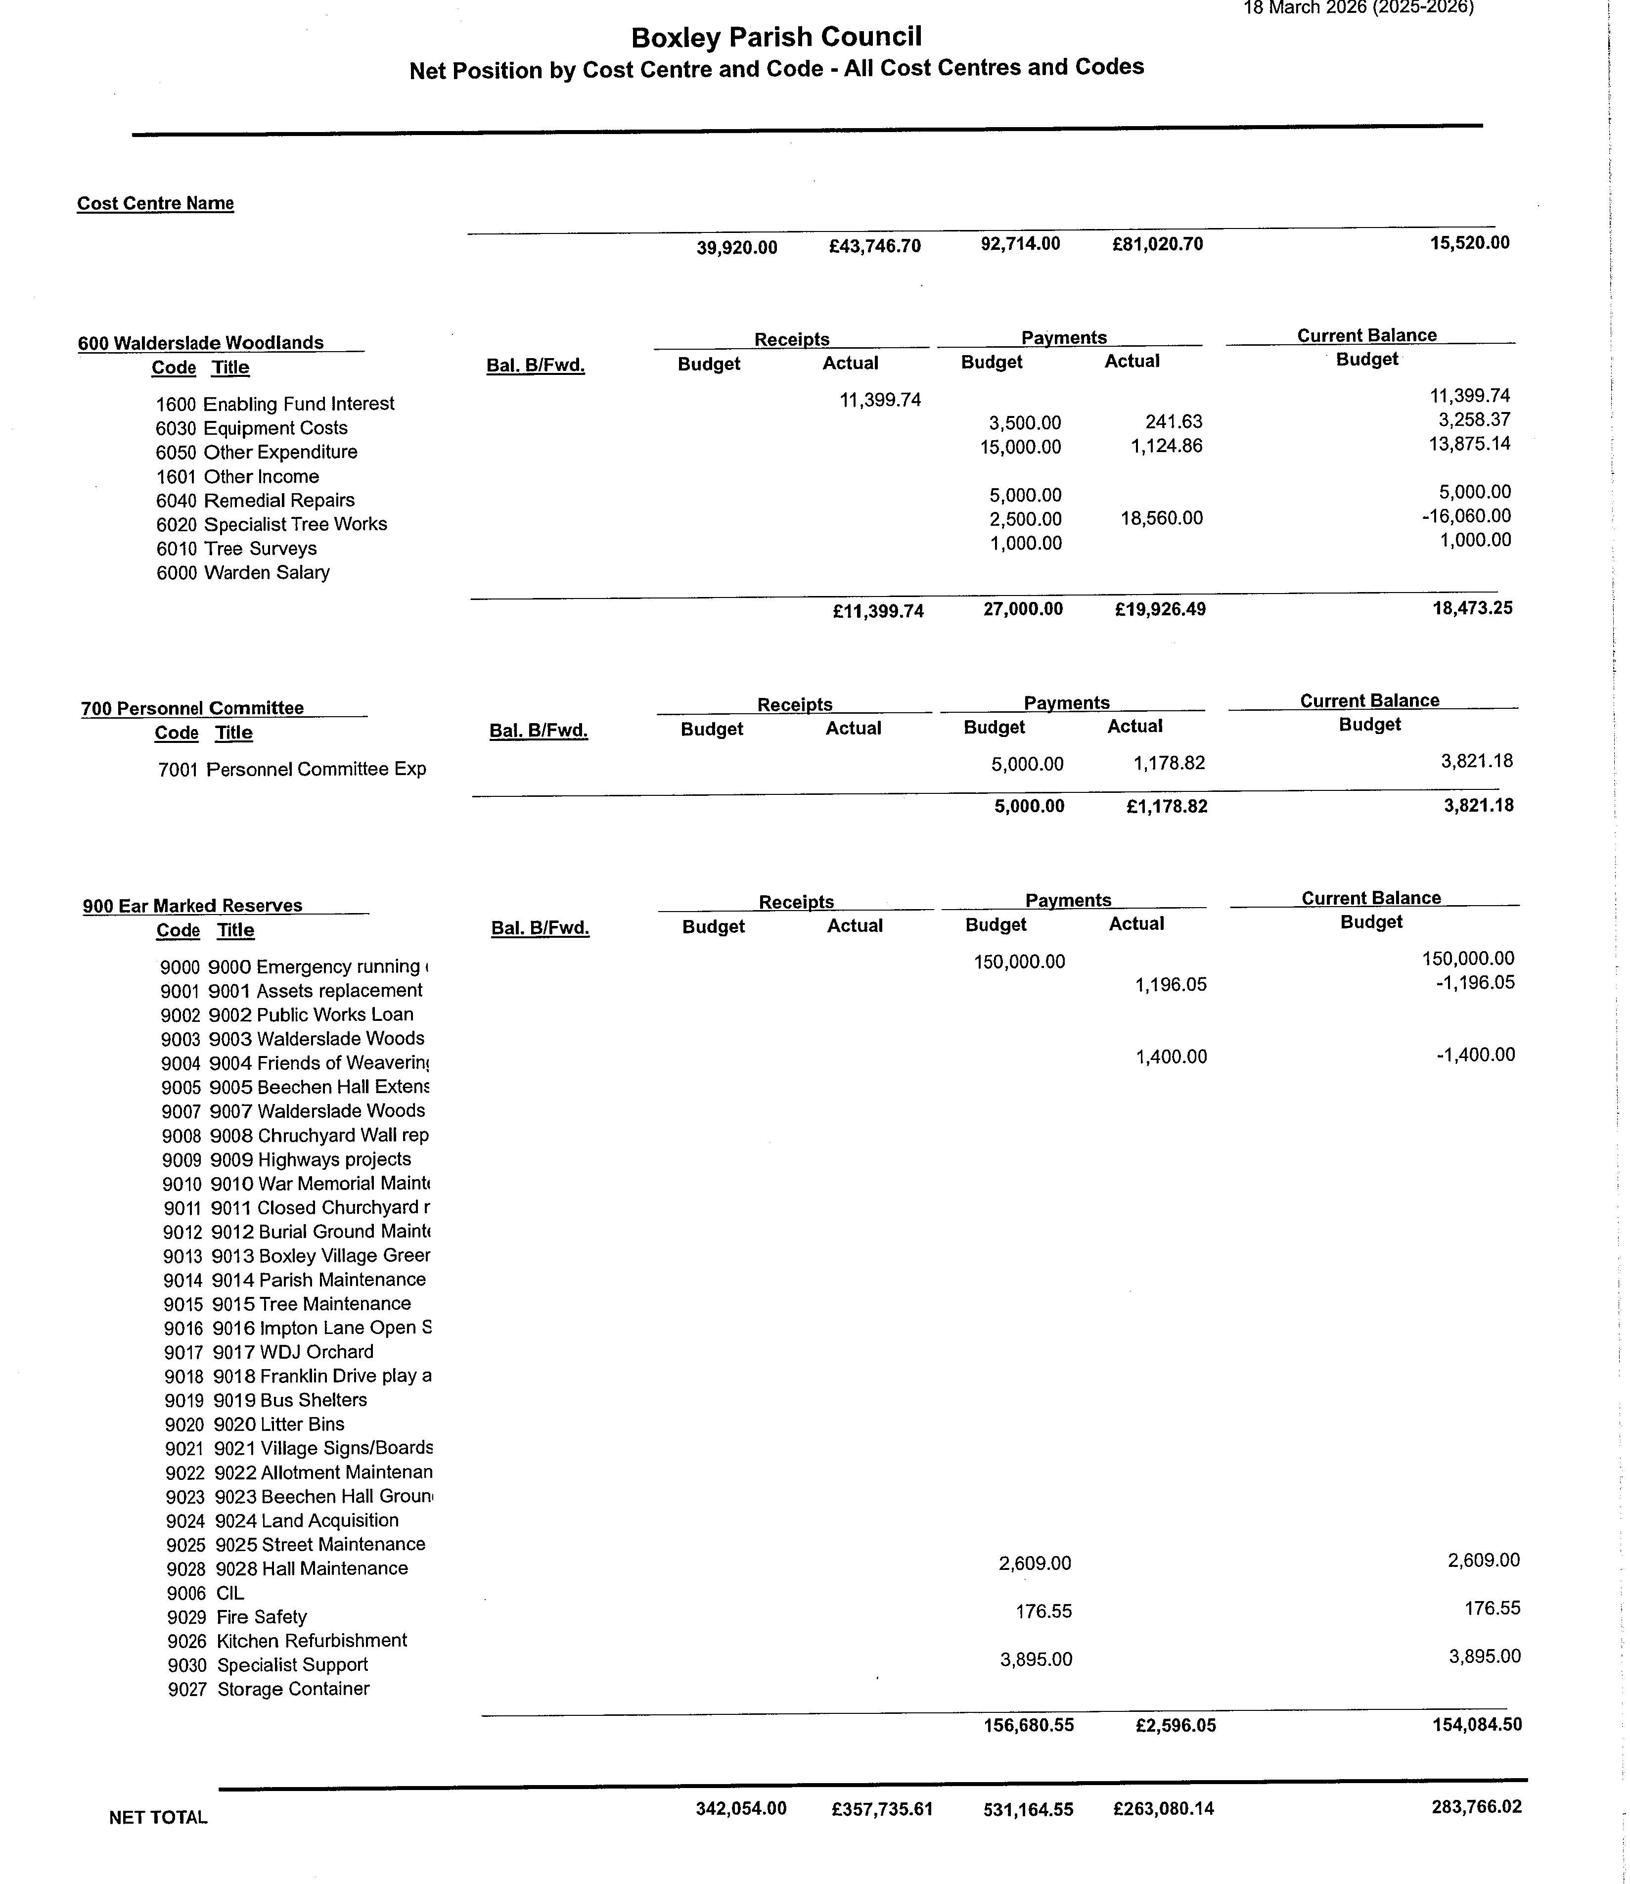

Item 6.6 Finance General

Preparations are under way for the end of year with reviews of all payments and coding, accruals, creditor and debtor reports being produced, Bank reconciliations, code transfers etc all being bought up to date for the 31 March. Once the end of year is completed the documents for Full Council approval will be produced and the AGAR submission pack produced.
The new accounting year is set up and just needs the budget figures added for next year and the carry over figures from this financial year.
The timesheets, annual leave forms and calculations for the new financial year need to be completed.

Item 6.7 Ear Marked Reserves Annual Review

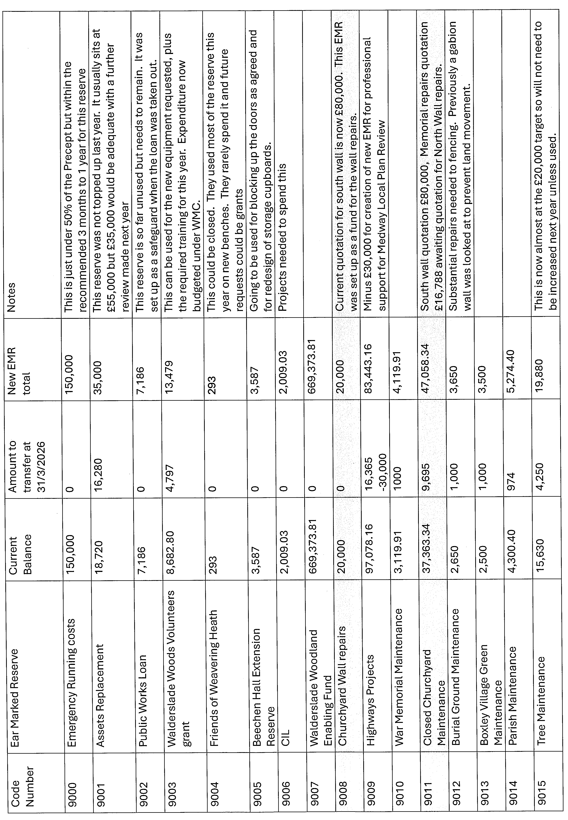
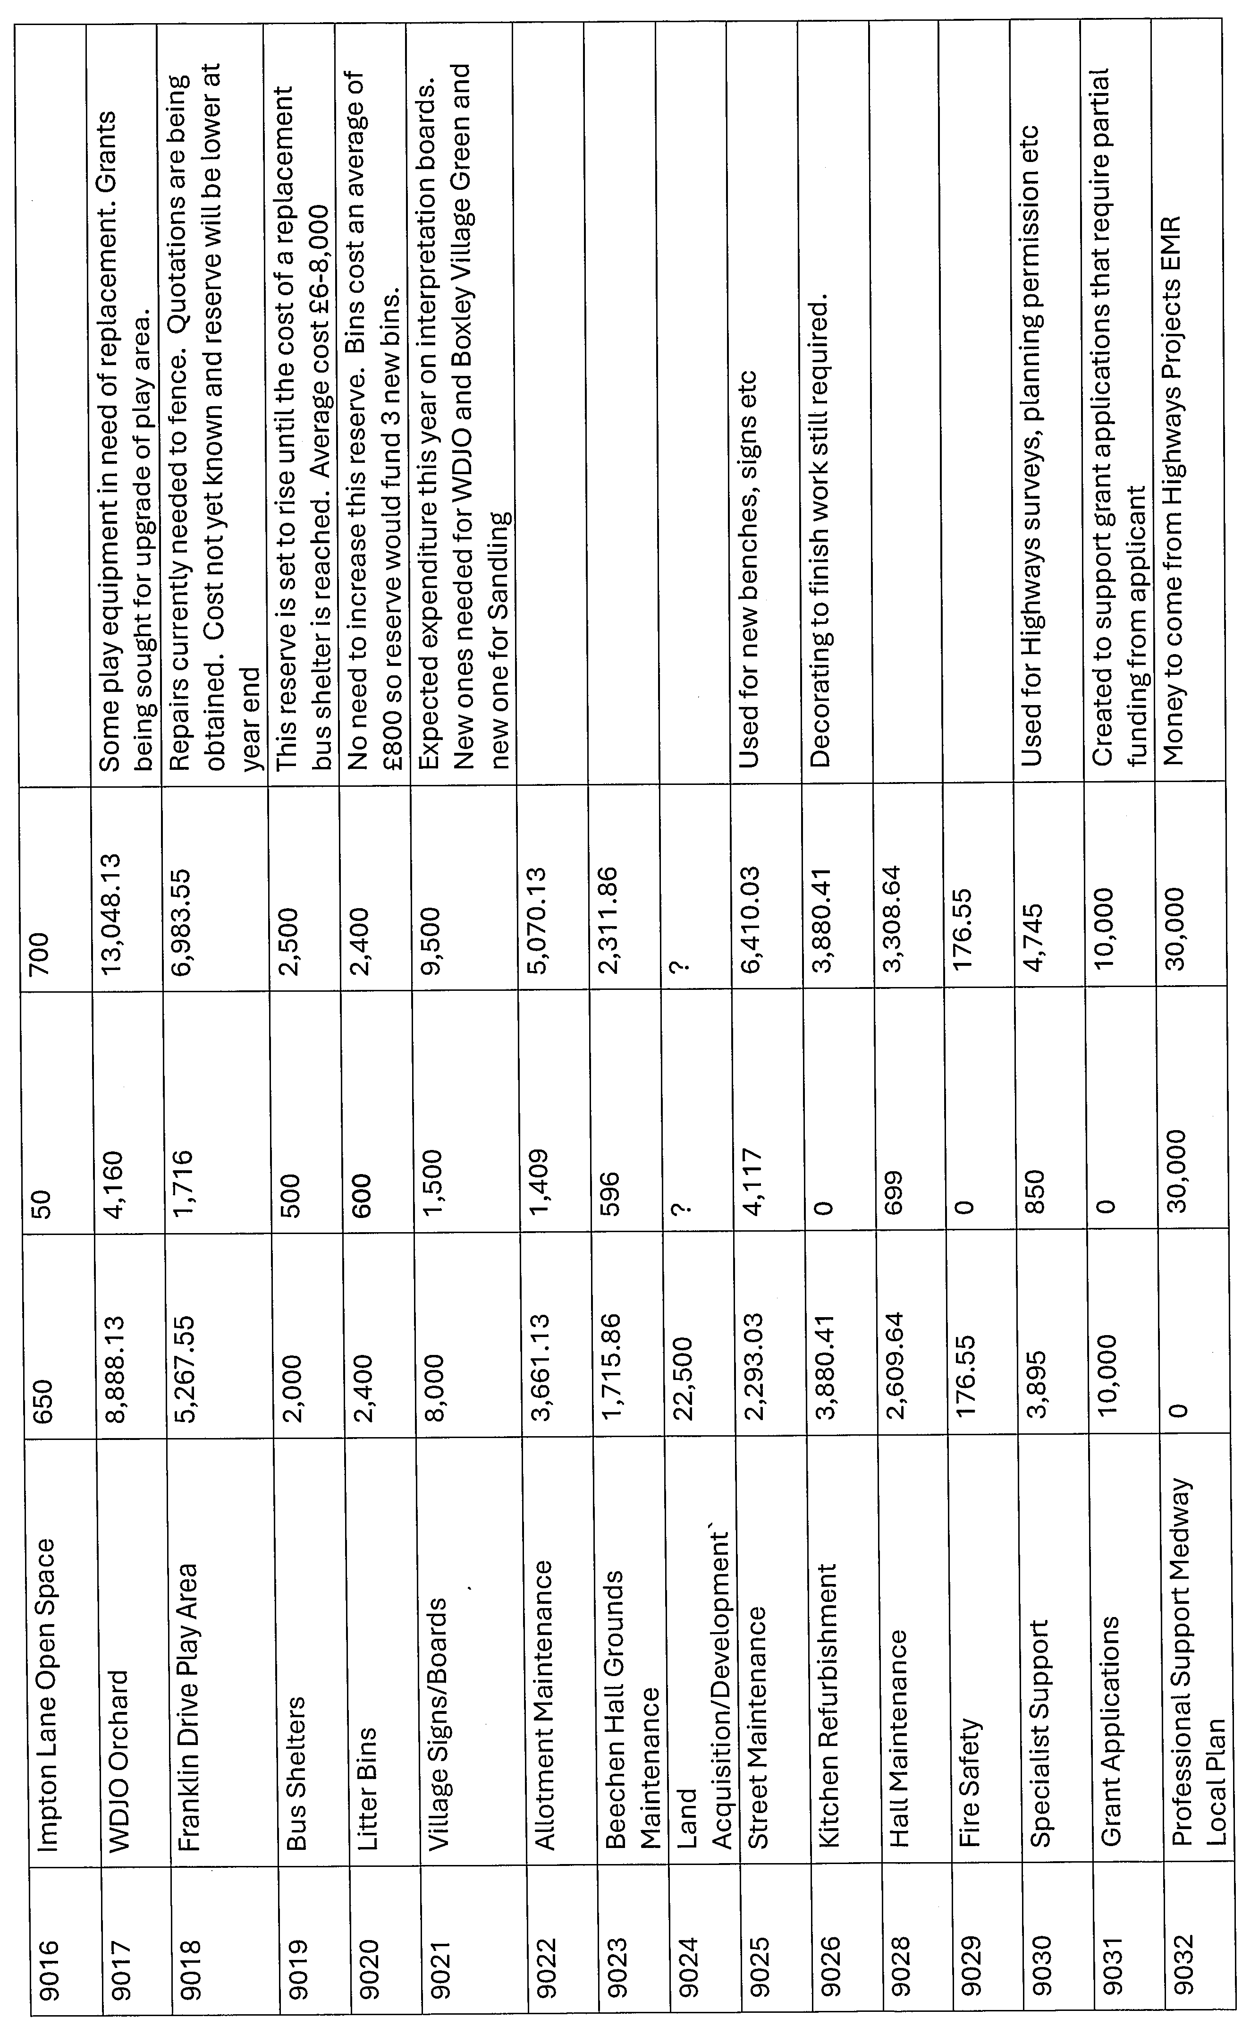
Item 6.8 To create a new reserve for Professional Representation for the Medway Local Plan

At the Environment Committee meeting held on 16 March 2026 it was agreed to create a new EMR using £30,000 from the Highways Improvement EMR as an agreement in principle to pay up to this figure for professional representation for BPC for the Medway Local Plan Review.

Item 6.9. Expenditure from Contingency Fund

At the Environment Committee meeting held on 16 March 2026 it was agreed to pay for a noise assessment survey at a cost of £1,500. It was suggested that the funds could come from the F&GP Contingency Fund. The Contingency fund currently has a remainder of £263. The Specialist Support EMR could be used for the remaining £1,237 or the entire £1,500 could come from the Specialist Support EMR.

Item 6.10. Regular Payments Review

Regular Payments
Item | Detail | Frequency | Cost | Notes
Unity Trust – Beechen Hall
MBC Rates | 70% | Monthly x 10 | 326.20 | Monthly direct debit
Refuse Collection | SUEZ | Monthly | £173.90 | Fluctuates, dependent on no. of lifts
Gas | Scottish Power | Monthly | £892.06 | Monthly Direct Debit
Electricity | Scottish Power | Monthly | £378.17 | Monthly Direct Debit
Water | Business Stream | Quarterly | £354.75 | Fluctuates dependent on usage
Salaries Hall |  | monthly | 2813.53 | Some variation if extra hours worked and mileage is not a constant figure. Figure includes cleaner who pays her own Tax and NI
Pensions Hall |  | monthly | 145.13
Employers NI |  | monthly | 347.98
Telephone | 50% | monthly | 52.62
IT Services | 30% | monthly | 141.82
Photocopier | 50% | Quarterly | 168.73
PRS Licence | PRS | annual | 304
MBC Premises License |  | Annual | 180
CCTV | Kent Security Systems | Annual | 160
Bookings/account system (50%) | Scribe (Starboard Systems) | Annual | 726 | Accounts £378 Bookings £348
Sanitary bins/ urinal water softener | Capital Cleaning | Monthly | 64.99
Fire Safety | Link Smoke Detection | Annual | 360 | Alarms, Extinguishers, emergency lighting
Gas Safety | Prestige Solar and Heating/Keemlaw | Annual | 292.50 | Annual maintenance/safety certificate
Legionella Testing | ARA Environmental Solutions Ltd | Annual | 330 | This included tank cleaning and sample testing
PAT Testing | All in One Electrical | Annual | 127.50
PWLB | PWLB | Bi-annual | 3592.69
Unity Trust Bank - Parish Council
IT Services | Northstar 70% | Monthly | 165.02
Telephone | 50% Vostel | Monthly | 52.62
Photocopier | 50% Agilico | Quarterly | 168.73
MBC Rates | 30% | Monthly x 10 | 139.00
Salaries - PC |  | Monthly | 4504.93 | Some variation if extra hours worked and mileage is not a constant figure
Pensions Employer |  | Monthly | 241.88
Employers NI |  | Monthly | 579.97
Internal Audit | L Robbins | Bi-annual | 245
External Audit | Forvis Mazars | Annual | 840
Councillor Allowance |  | Monthly | £178.6
Chairman’s Allowance | Chairman | Monthly | £86.78
Website | Teec | Annual | 432
Website | Ionos Cloud | Annual | 10
Accounts software | 50% Scribe | Annual | 378
Allotment Pest Control | DNA Pest Control | Monthly | 110
Allotment Water | Southern Water | Quarterly | 458.05 | All 4 bills added and divided by 4. Water turned off in winter
Playground inspections | RoSPA | Annual | 172 | Franklin Drive and WDJO

Item 6.11. Insurance Cover – Annual Review

The policy renewal is not available in March. The policy expires on the 31 May. As the policy will renew before the date of the next meeting could a working party consisting of the Chair and Vice-Chair of F&GP and Clerk be set up to handle the renewal. The working group will circulate the renewal quotation to F&GP members for an out of meeting decision to be ratified at the next Committee meeting.

The insurance brokers are in possession of the new asset register and are using their software to generate forecast figures for the insurance values of assets.

Item 7.1 Finance and General Purposes Committee Terms of Reference



Finance and General Purposes Committee Terms of Reference

Role
The role of the Finance and General Purposes Committee is to oversee and manage the following aspects of the financial administration of the Parish Council including arrangements for the preparation and audit of the Council’s systems and accounts.
Responsibilities
The Finance and General Purposes Committee shall:

- Develop and, where necessary, recommend to the Parish Council policies and procedures for the financial management of the Council. Advise the Parish Council and Committees, as necessary.

- Oversee the investment strategies of the Parish Council and advise accordingly.

- Receive and consider annual draft budgets prepared by each Committee or budget holders.

- Recommend an annual budget and precept for the Council

- Monitor reserves to ensure that surpluses are not built up other than for working capital or for earmarked projects and known liabilities, ensuring that sufficient reserves are retained for future maintenance, replacement or upgrading of items for which the Council is responsible.

- Monitor income and expenditure against budget and take/recommend appropriate action to the Council or Committees.

- Consider requests to vire, where necessary, from the Contingency Budget to other budget headings.

- Undertake a financial risk analysis annually and review the Council’s insurance arrangements to ensure that the Council is adequately insured.

- Receive and review Audit Reports and ensure the implementation of any recommendations.

- Deal with requests for grants* and Section 137 donations. *Excluding Village Hall Grants which come under the remit of the Estates Committee.

- Make recommendation to the Council on the implications of applying for a Public Works Loan. If approved to manage the Council’s loan debt.

Committee Budget

1. To draft the Committee budget and decide priority ratings for the Finance and General Purposes Committee (for consideration with the recommendations from other Committees).
2. To manage the budget and vire, where necessary, between budgets held and managed by the Committee.
3. To manage, according to Financial Regulations, contracts and tenders for any projects within the budget of the Committee.

Membership

1. The Committee shall consist of up to Eight Councillors to include the Chairs of Committees that oversee a budget. In addition the Chairman and Vice-Chairman of the Parish Council shall be members of every Committee unless they signify that they do not wish to serve.
2. The Committee may appoint working parties to undertake any specific project work as necessary

Presiding

The Chairman or Vice-Chairman of the Committee shall preside at all meetings of the Committee. If they are not present a Chairman shall be elected for the meeting from those members present.

Other

The Parish Council has the right to identify issues that will be dealt with at the full meeting of the Parish Council.
The Parish Council may allocate to the Committee matters outside of the above remit with the agreement of the Chair and Vice Chair of the Committee.

These Terms of Reference to be reviewed annually in May.

Adopted by Council July 2025
Item 8. New Office Equipment/service provision

New office equipment

The agreed budget for 2026-27 has provision for replacing the office laptops. The budget set for replacement equipment is £3,600. The laptops are on a 3 year replacement schedule and are now 4 years old. One of the laptops is already having an issue. The Property Manger needs to connect his laptop to a monitor to make his workplace DSE compliant.

Below is the quotation for the new laptops and screens. Blue is from Northstar and black is clerks notes.

Lenovo ThinkBook 16 G8 IRL 16" Notebook,
Intel Core i5 13th Gen i5 (13th gen), 16 Gb RAM, 256 Gb SSD, Windows 11 Pro, Onsite warranty. £599+VAT & delivery each. 4 required.

1 x iiyama 24” HDMI monitor £99+VAT for the Property Manager. (Clerk would like one with anti-glare tint which is better for longer screen time and position of desk, found this online and will get a quote for similar from Northstar before the meeting iiyama ProLite monitor T2454MSC-B3AG 24", InCell Projective Capacitive 10pt touch, Anti-glare coating, IPS, HDMI, flexible stand £211.20 exc. VAT)

Installation if carried out at the same time £716+VAT or if done individually would be £276+VAT each. So there is quite a saving if done at the same time. Both options include a 20% discount off of our non-support contract client rate.

Total cost for 4 laptops and 2 screens plus installation is £3,480 plus one additional docking station. Budget for expenditure £3,600.

Revised Service provision

While I have you, we’ve been reviewing our IT support pricing and realised we haven’t increased your rate for quite some time. While we’ve done our best to absorb rising costs, we do now need to make a small adjustment up to £27.50+VAT per computer, per month. But we will continue to provide basic email support to the councillors when needed in this too.

Because you’ve been such a valued long-term client, we’ll be applying a loyalty discount, so your new rate remains preferential. We really appreciate your continued trust in us and look forward to supporting you for many years to come. Please feel free to call if you’d like to talk it through.

Below is the latest invoice from Northstar outlining the services provided for 4 laptops 5 office email addresses and 15 Councillor email addresses. Expenditure is split between the hall and PC at 30/70%.
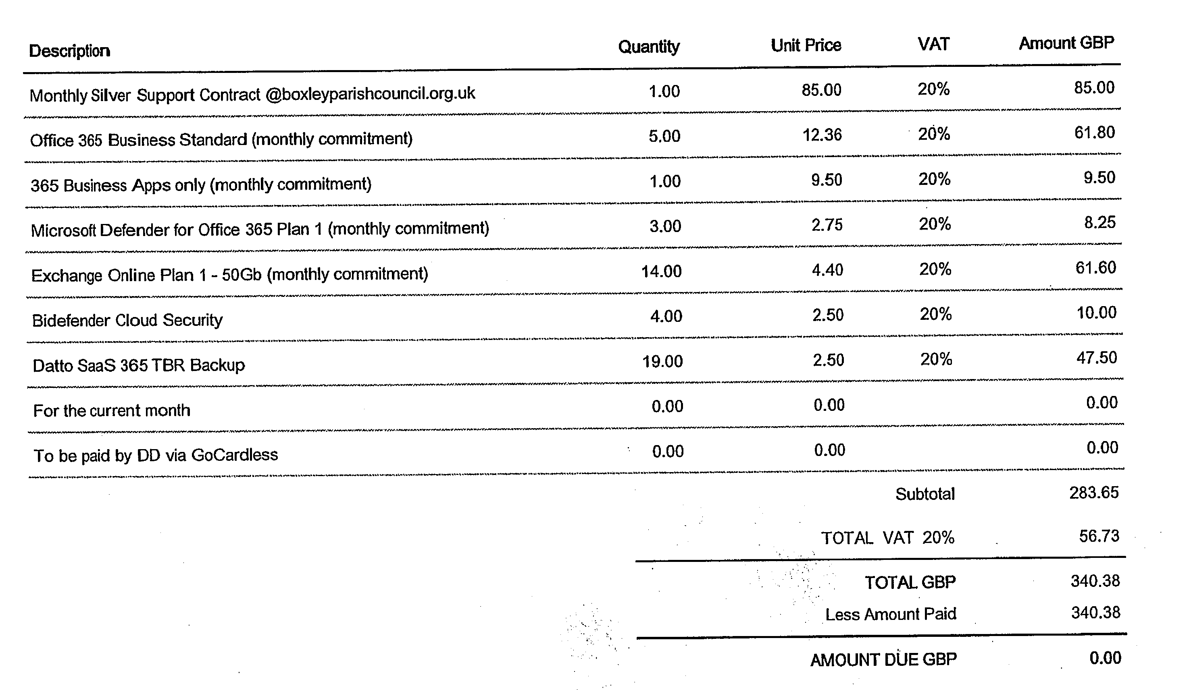

9. 5 Year Strategic Plan

The projects have been split into Committee categories and this has been circulated to members.

10. Internal Auditor

Company 1 | Please accept this document as a quote for two internal audit reviews for Boxley Parish Council 2026/27. This is based on 5 days per year at a daily rate of £400 (excluding VAT and travel expenses).  Total amount estimated: £2000 plus vat & expenses
Company 2 | Overview of Services  As part of our comprehensive support for town and parish councils, Company 2 provides a professional internal audit service. This is delivered in full compliance with the Smaller Authorities Proper Practices Panel (SAPPP) Practitioner’s Guide, reflecting current guidelines and accounting standards.  Audit Schedule  We generally carry out two audits per year as standard:  • Interim Audit: Focuses on governance and accountability, including procedural aspects such as Financial Regulations, Standing Orders, risk assessments, internal control systems, and policies.  • Final Audit: Concentrates on financial matters, including verification of the Annual Governance and Accountability Return (AGAR) and all supporting documentation for submission to external auditors.  This two-stage approach allows councils to identify and address weaknesses before the final internal audit report is completed.  Flexible and Responsive Service  We understand that each council has unique needs, so we’re happy to offer customised audit visit schedules and respond to queries throughout the year. Our flexible service ensures your council receives the support it requires when it's needed most.  Sector Expertise and Independence  Company 2 are founder members of the Internal Audit Forum, who work in partnership with the National Association of Local Councils (NALC) to promote continuous internal audit improvement in the local council sector.  One of our directors is the internal audit representative on the SAPPP, which is responsible for issuing proper practices about governance and accounts of smaller authorities.  Company 2, previously has over 20 years of experience in conducting internal audits for local councils. Our auditors have deep sector knowledge and can rotate between clients to ensure full independence throughout your engagement.  In the 2025/26 financial year, we supported over 330 councils with their internal audit requirements, including:  • Small councils exempt from limited assurance reviews  • Larger town and parish councils managing multi-million-pound budgets and complex financial systems  Audits are conducted either on-site or remotely, based on your council's preferences and circumstances.  We publish on our website an annual internal audit guide, which enables our councils to prepare for their audits by providing details of the information we review at each visit and reminding them of the publication requirements on the council’s website.  Fees and Charges  Our pricing for internal audits for the financial year 2026 is as follows:  • Precept below £1 million - £80 per hour + VAT  • Precept £1 million and above - £85 per hour + VAT  • Travel costs (for on-site visits) are billed at the standard HMRC rate of 45p per mile  • No charges for travel time  Audit duration depends on your council’s financial complexity. Once appointed, your assigned auditor will be happy to discuss a personalised estimate and timeline.  Engagement Options  We offer one-year and three-year engagement periods. If you commit to a three-year term, we guarantee that your hourly rate will remain fixed for the full duration of the agreement.  Added Benefits  As a client of Company 2, you will gain access to discounted rates on our training programme for  officers and councillors. Details of upcoming courses can be found at:
Company 3 | Completion of the Annual Internal Audit Report. Concentration on the trail from the annual accounting statement back to the cashbook and bank statements while testing transactions to invoices or other supporting documentation. Review of the Council’s minutes for compliance with legal obligations, its general functioning and for mutual consistency with the accounts.  Cost £245 for 2 internal audits
Company 4 | A review of the following AGAR Internal Audit Control objectives is carried out to ensure they are being achieved to a standard adequate to meet the needs of the Council:  Appropriate accounting records have been properly kept throughout the year.  This authority complied with its financial regulations, payments were supported by invoices, all expenditure was approved and VAT appropriately accounted for.  This authority assessed the significant risks to achieving its objectives and reviewed the adequacy of arrangements to manage these.  The precept or rates requirement resulted from an adequate budgetary process; progress against the budget was regularly monitored; and reserves were appropriate.  Expected income was fully received based on correct prices, properly recorded and promptly banked; and VAT appropriately accounted for.  Where applicable, Petty Cash payments were properly supported by receipts, all petty cash expenditure was approved and VAT appropriately accounted for.  Salaries to employees and allowances to members were paid in accordance with the authority’s approvals, and PAYE and NI requirements were properly applied.  Asset and investment registers were complete and accurate and properly maintained. This section/assurance should be extended to include loans to or by the authority.  Periodic bank account reconciliations were properly carried out during the year.  Accounting statements prepared during the year were prepared on the correct accounting basis (receipts and payments or income and expenditure), agreed to the cashbook, supported by an adequate audit trail from underlying records and, where appropriate, debtors and creditors were properly recorded.  If the authority certified itself as exempt from a limited assurance review in the prior year, it met the exemption criteria and correctly declared itself exempt.  The authority publishes information on a free to access website / web page, up to date at the time of the internal audit in accordance with the relevant legislation.  The authority, during the previous year, correctly provided for the period for the exercise of public rights as required by the Accounts and Audit Regulations.  The authority complied with the publication requirements for the prior year AGAR.  Trust funds (including charitable) - the Council met its responsibilities as a trust  Cost £1,245 plus VAT and expenses

